MA 323 (2020) Monte Carlo Simulation Lab 01

**Name:** Udandarao Sai Sandeep

**Roll Number:** 180123063

**Dept.:** Mathematics and Computing

**Q1.** The Table given below shows the sequence generated for:

1. a = 6, b = 0, m = 11

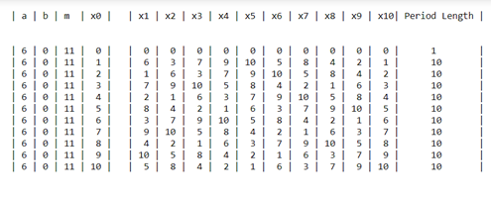

We can observe that for x0 = 0, the period length is 1.

We can observe that for all other values of x0, the period length is 10.

Since 10 = (m-1), this is the maximum period length that can be achieved.

1. a = 3, b = 0, m = 11

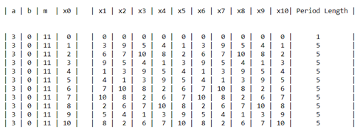

We can observe that for x0 = 0, the period length is 1.

We can observe that for all other values of x0, the period length is 5.

So, the best choice is: a = 6, b = 0, m = 11, x0 = 1 to 10

If we take any one of the above choices, 10 distinct values (full period) appear before repetition. This is because the given values of a, b and m follow the condition for full period.

• b=0 • m=11 (prime number) • 11 divides 610-1 • 11 does not divides 6j-1 for j **∈** { 1, 2,…., 9 }

**Q2.**

5 random values of x0 (for each case) were chosen using random module in python. From the histograms and the frequency tables, it can be observed that frequency of each category is approximately equal, indicating that the values generated by the linear congruence generator is uniformly distributed between 0 and 1. The fraction of values falling in any subinterval is approximately equal to its length. Hence, the generator mimics uniformity.

**Note**: For the first graph of each case, a=1597, b = 51749, and second graph of each case, a=51749, b =1597.

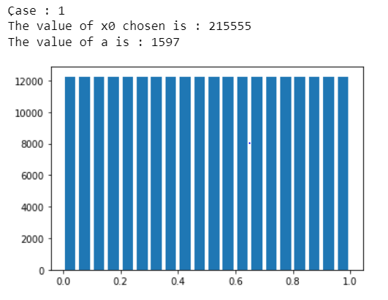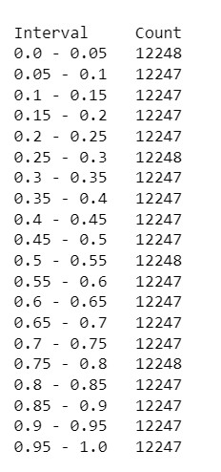

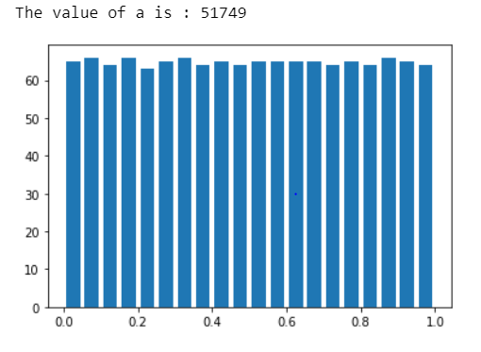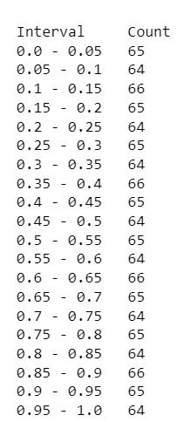

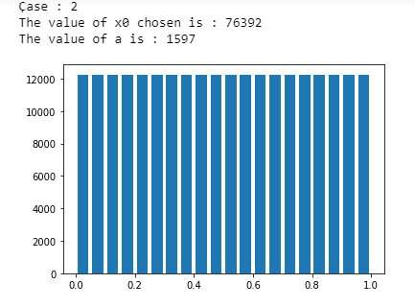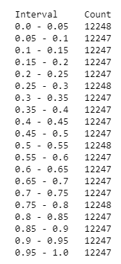

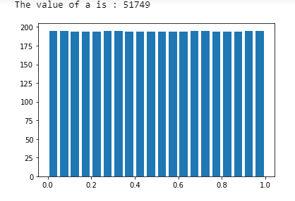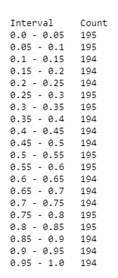

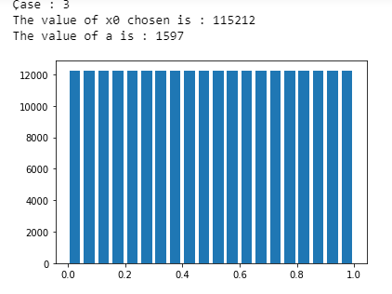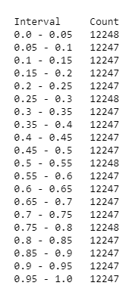

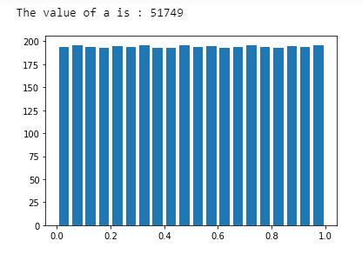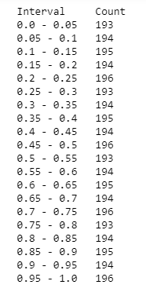

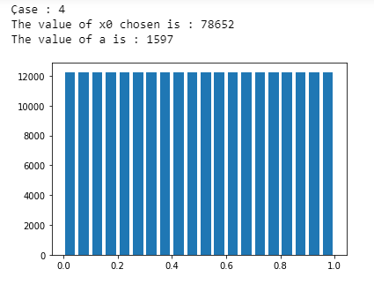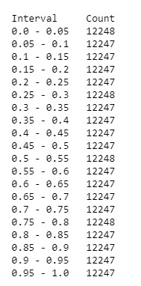

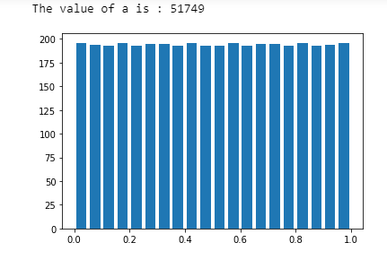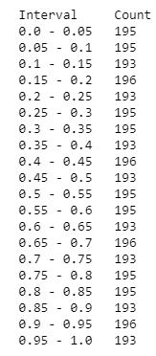

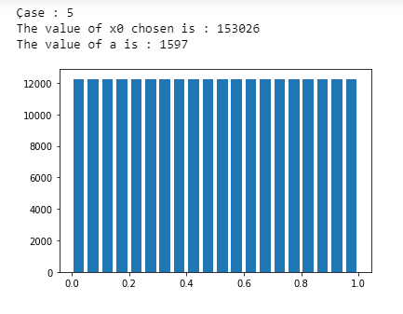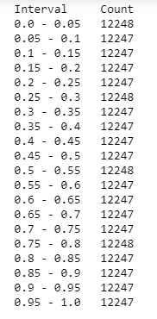

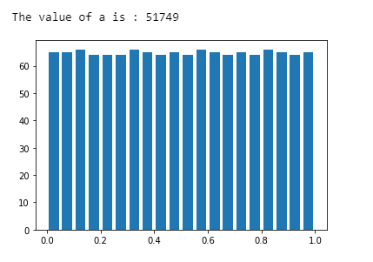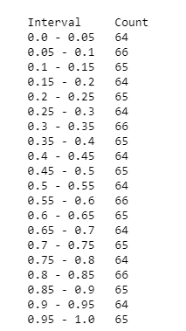

**Q3.**

As specified by the question, 2-D plot was created using the points (ui-1, ui) until repetition.

We are getting a pattern (a series of straight lines with same slope) as shown below.

